https://in.mathworks.com/products/simscape-electrical.html

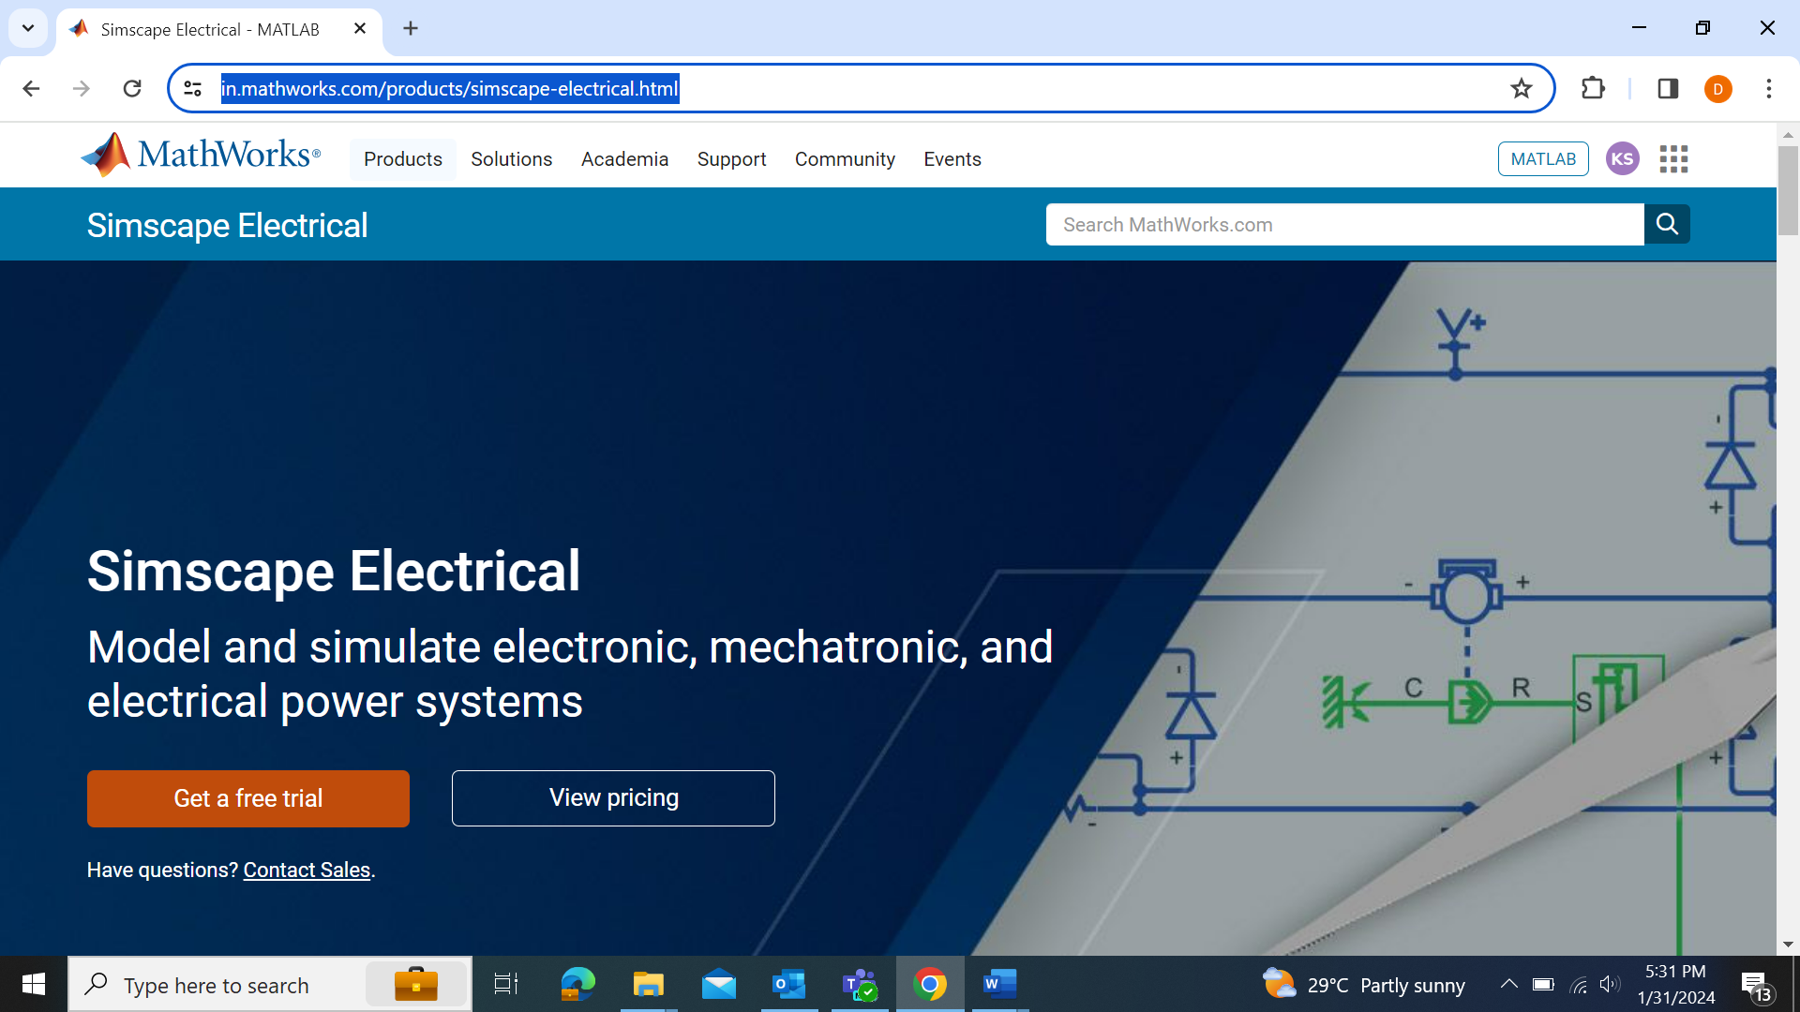
Click Get a free trial
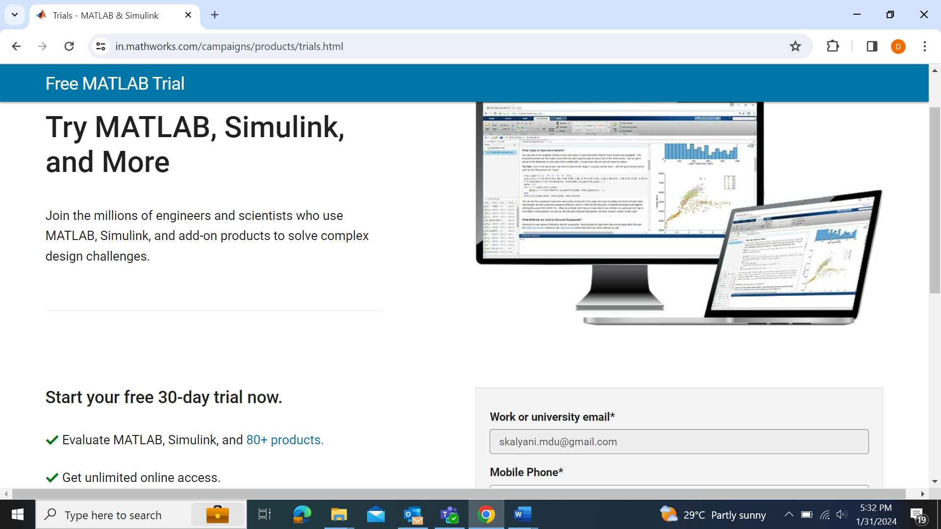

Scroll down and enter the following details:
- Your Email Id
- Mobile Phone number
- Simscape for Physical Modelling
and press Submit Button
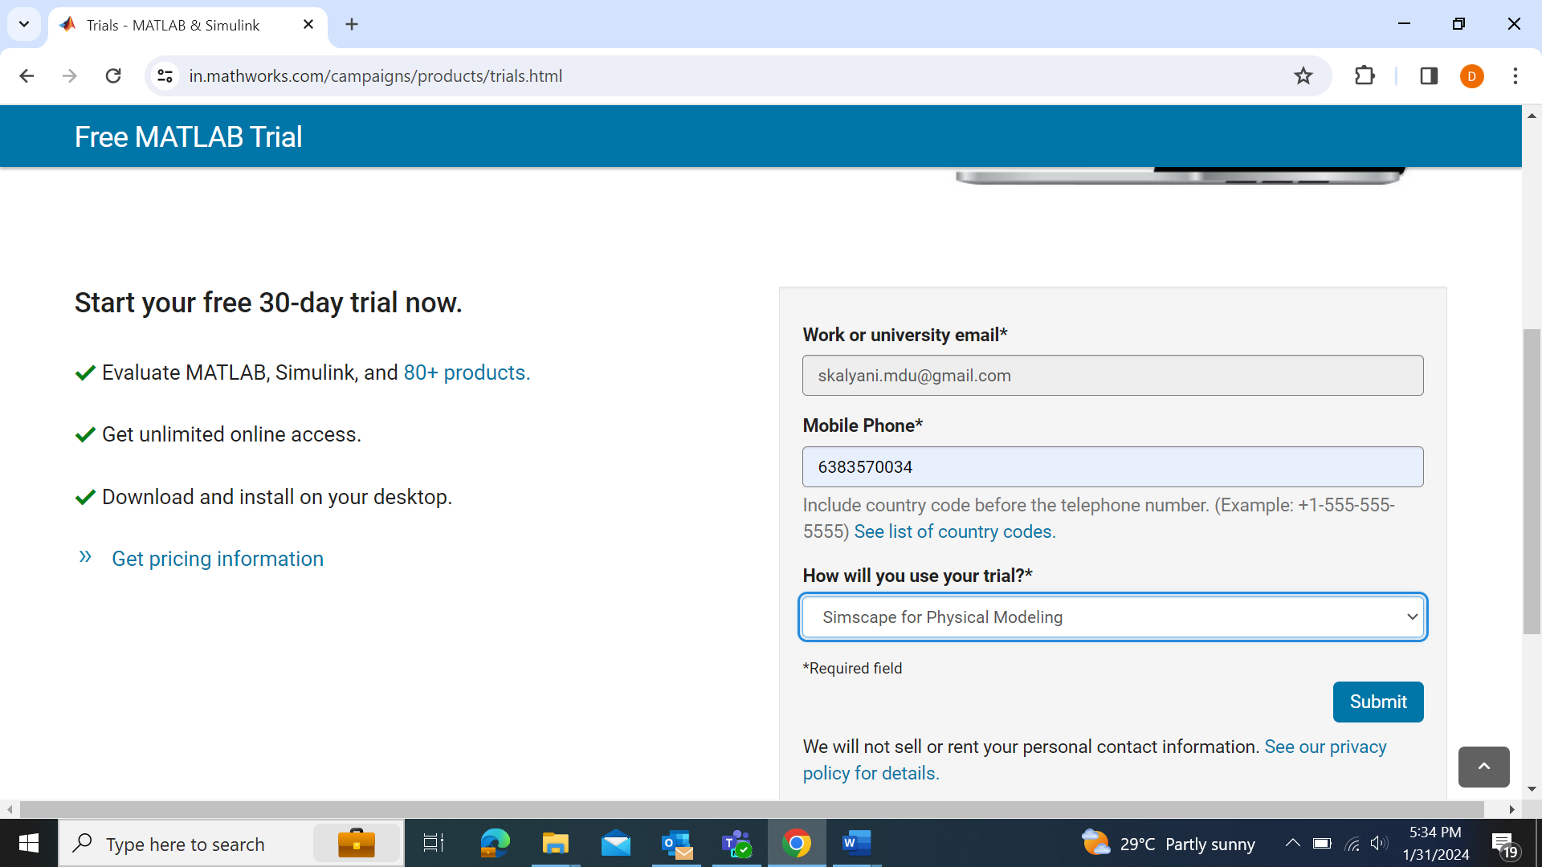
Now Simscape will be added in your MATLAB Online Toolbox and your basic version of Online MATLAB will become MATLAB Online

Click MATLAB Online and start working

